Circuit Board recycling machine Technology parameters
Electric power | 22KW
Inout voltage | 380V,50HZ,3phases
Knives | 10PCS
Output(Min) | 800-1000KG/Hour
Plastic shreds width | 5mm-50mm(adjustable)
Noise | Less than 80db
MeasuresL*W*H | 1250*1100*2050MM
Weight | 1450KG
Package | Wooden cases
Warranty | Three years

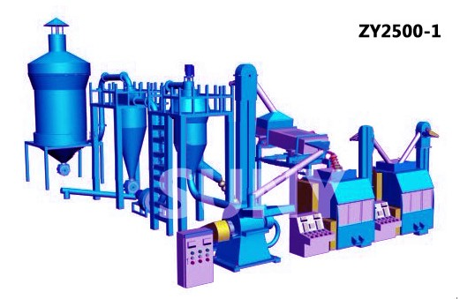
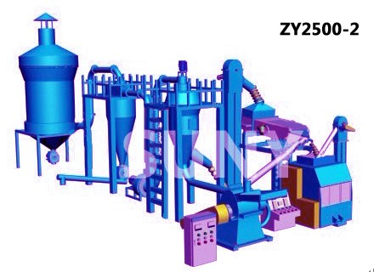

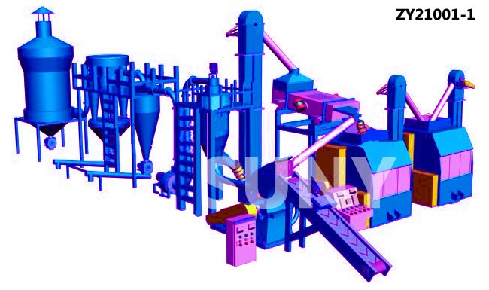
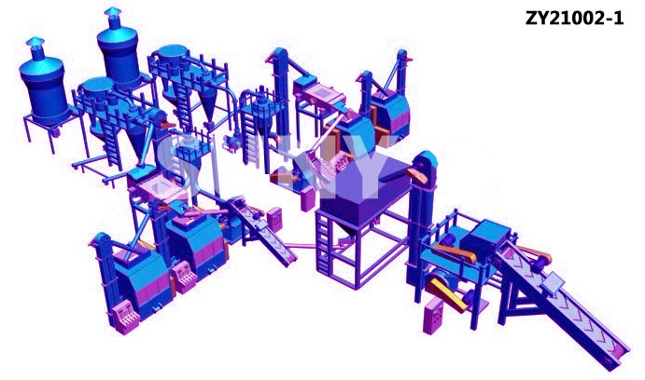
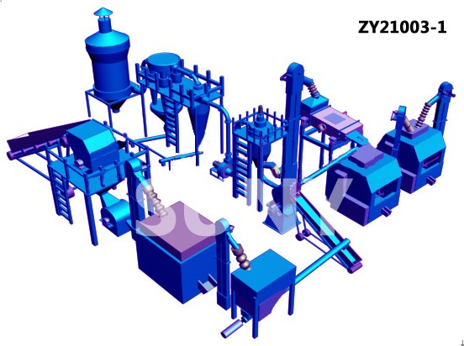
E-mail:jackhao@zzzyjx.cn Tel:0086-371-86617456
Mobil phone:0086-13283840926 Jack Hao www.zygreenmachine.com
If you are intrested in our products,we are glad to help you.
Please contact us at anytime for more information.

